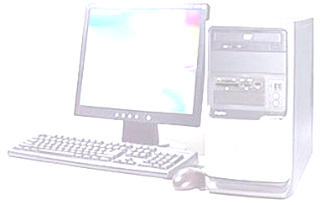**1. Les réseaux**

**a) Définition**

**b) Classification des réseaux**

**c) Les différentes topologies de réseaux**

**2. Architecture matérielle des réseaux.**

**a) Les liens : la paire torsadée**

**b) Les liens** : **le câble coaxial**

**c) Les liens : La fibre optique**

**d) Les nœuds: le hub ou concentrateur**

**e) Les nœuds : Le switch ou commutateur**

**f) Les nœuds : le routeur**

**3. L’architecture**

**4. La communication**

**a) Elle peut être filaire.**

**b) Transmission sans fil : WLAN, WPAN**

b1) transmission sans fil **WLAN**

b2) transmission sans fil **WPAN** : **Bluetooth** (norme 802.15) et **infrarouge**

**5. Les protocoles**

**a) Le modèle OSI**

**b) Le protocole TCP**

**c) Les adresses IP**

**1. Les réseaux**

**a) Définition**

Un ***réseau*** est un ensemble de _ _ _ _ (1 nœud est une interface réseau comme un routeur, commutateur, …) _ _ _ _ _ _ _ _ _ _ _ _ _ _ _ _ _ _ _ (cuivre et optique) _ _ _ _ _ _ _ _ _ _ _ _ _ _ , sur lesquels circulent des flux (infos souvent binaires, et structurés selon des ***protocoles***).

Ces réseaux relient des _ _ _ _ _ _ _ _ _ _ _ _ _ _ _ _ _ _ _ _ _ _ _ _ _ _ _ _ _ _ _ _ _ _ _ _ _ _ _ _ _ _ tels que des ordinateurs, des téléphones, des *Smartphones*, des télécopieurs, des consoles de jeux, etc. … pour leur permettre de communiquer entre eux.

**b) Classification des réseaux**

**Les LAN [ _ _ _ _ _ _ _ _ _ _ _ _ _ _ _ _ _ _ _ _ _ _ _ _ ] :**

* _ _ _ _ _ _ _ _ _ _ _ _ _ _ _ _ _ _ _ _ _ _ _ _ _ _ _ _ _ _ _ _ _ _ _ _ _ __ _ _ _ _ _ _ _ _ _ _ _ _ _ _ _ _ _ _ _ _ _ _ _ _ _ _ _ _ _ _ _ _ _ _ _ _ _ _ _ _ _ _ _ _ _ _ _ _ _ _ _ _ _ _ _ _ _ _ _ _ _ _ _ _ _ _
* _ _ _ _ _ _ _ _ _ _ _ _ _ _ _ _ _ _ _ _ _ _ _ _ _ _ _ _ _ _ _ _ _ _ _ _ _ _ _ _ _ _
* Ce type de réseau utilise des communications via des _ _ _ _ _ _ _ _ _ _ _ _ _ _ _ _ _ _ _ _ _ _ et des _ _ _ _ _ _ _ _ _ _ _ _ _ _ _ _ _ _ _ _ _ _ _ _

**Les MAN [ _ _ _ _ _ _ _ _ _ _ _ _ _ _ _ _ _ _ _ _ _ _ _ _ ] :**

* _ _ _ _ _ _ _ _ _ _ _ _ _ _ _ _ _ _ _ _ _ _ _ _ _ _ _ _ _ _ _ _ _ _ _ _ _ __ _ _ _ _ _ _ _ _ _ _ _ _ _ _ _ _ _ _ _ _ _ _ _ _ _ _ _ _ _ _ _ _ _ _ _ _ _ _ _ _ _ _ _ _ _ _ _ _ _ _ _ __ _ _ _ _ _ _ _ _ _ _ _ _ _ _ (Exemple : un réseau d’université reliant les différents sites et laboratoires)
* Ce type de réseau utilise des communications via _ _ _ _ _ _ _ _ _ _ _ _ _ _ _ _ _ _ _ _ _ _ _ _ _ _ _ _ _ _ _ _ _ _ _ _ _ _ _ _ _ _ _ _ _ _ _ _ _ .

**Les WAN [ _ _ _ _ _ _ _ _ _ _ _ _ _ _ _ _ _ _ _ _ _ _ _ _ ] :**

* _ _ _ _ _ _ _ _ _ _ _ _ _ _ _ _ _ _ _ _ _ _ _ _ _ _ _ _ _ _ _ _ _ _ _ _ _ __ _ _ _ _ _ _ _ _ _ _ _ _ _ _ _ _ _ _ _ _ _ _ _ _ _ _ _ _ _ _ _ _ _ _ _ _ _ _ _ (exemple : Internet).
* Ce type de réseau utilise des communications via _ _ _ _ _ _ _ _ _ _ _ _ _ _ _ _ _ _ _ _ _ _ _ _ _ _ _ _ _ _ _ _ _ _ _ _ _ _ _ _ _ _ _ _ _ _ _ _ _ .

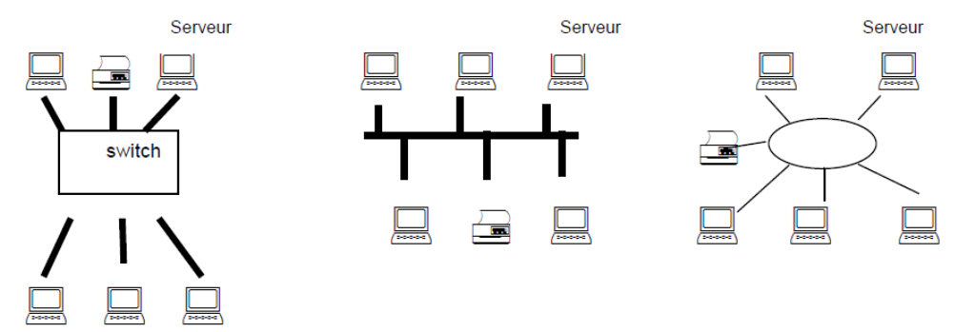**c) Les différentes topologies de réseaux**

***_ _ _ _ _ _ _ _ _ _ _ _ _ _ _ _ _ _ _ _ _ _ _ _ _ _ _ _ _ _***

**2. Architecture matérielle des réseaux.**

**a) Les liens : la paire torsadée [ _ _ _ _ _ _ _ _ _ _ _ _ _ _ _ _ _ _ _ _ _ _ _ _ _ _ _ _ _ _ _ _ ] :**

Elle est composée de paires de fils de cuivre, elle est généralement munie d’un blindage électromagnétique à base de cuivre ou d’aluminium. Elle est peu onéreuse, on la trouve dans les LAN, la vitesse de transmission est faible

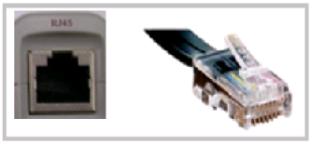(_ _ _ _ _ _ _ _ _ _ _ _ _ _ _ _ _ _ _ _ _ _ _ _ _ _ _ _ _ _ _ _ _ _ _ _ _ _ _ _ _ _ _ _ _ _ _ _ _ _ _ _ _ _ _ ).





Exemple : la prise **RJ45** est très utilisée pour les connexions aux réseaux informatiques. Le câble utilisé est un câble de paires torsadées.

**b) Les liens** : **le câble coaxial**

Il est muni d’un blindage électromagnétique à base de cuivre ou d’aluminium. Il est plus onéreux que la paire torsadée, on le trouve dans les LAN. ***Il est en perte d’utilisation***.

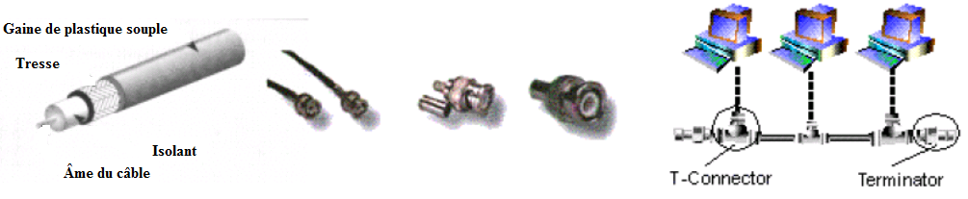

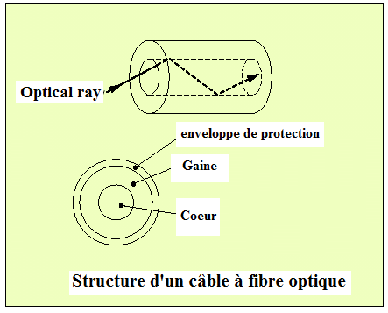**c) Les liens : La fibre optique**

Une fibre optique est constituée de 3 éléments :

* un fil de silice appelé _ _ _ _ _ de très faible diamètre

(de l’ordre de la longueur d’onde du signal transmis) ;

* une gaine appelée _ _ _ _ _ qui entoure le cœur ;
* une enveloppe de protection.

_ _ _ _ _ _ _ _ _ _ _ _ _ _ _ _ _ _ _ _ _ _ _ _ _ _ _ _ _ _ _ _ _ _ _ _ _ _ _ _ _ _ _ _ _ _ _ _ _ _ _ _ _ _ _ _ _ _ _ _ _ _ _ _ _ _ _ _ _ _ _ _ _ _ _ _ _ _ _ _ _ _ _ _ _ _ _ _ _ _. La fibre optique est un support privilégié pour les transmissions à haut débit, mais son coût est bien plus élevé que le support cuivre. La bande passante est très large et les débits sont de l’ordre du Giga bits/seconde.

Un signal n’a besoin d’être régénéré que tous les 500 km (mesure en laboratoire). Par exemple, le câble utilisé pour relier Marseille et Singapour, possède un pas de régénération de 150 km.

_ _ _ _ _ _ _ _ _ _ _ _ _ _ _ _ _ _ _ _ _ _ _ _ _ _ _ _ _ _ _ _ _ _ _ _ _ _ _ _ _ _ _ _ _ _ _ _ _ _ _ _ _ _ _ _ _ _ _ _ _ _ _ _ _ _ _ _ _ _ _ _ _ _ _ _ _ _ _ _ _ _ _ _ _ _ _ _ _ _ _ _ _ _ _ _ _ _ _ _ _ _ _ _ _ _ _ _

Deux types de fibres existent sur le marché : _ _ _ _ _ _ _ _ _ _ _ _ _ _ _ _ _ _ _ _ _ _ _ _ _ _ _ _ _ . La fibre monomode offre de meilleurs performances mais coûte plus cher que le multimode, elle est essentiellement utilisée pour des distances importantes entre réseaux

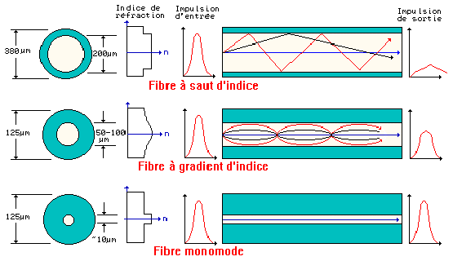

Le tableau ci-dessous regroupe quelques caractéristiques de ces trois supports.

|  |  |  |  |  |
| --- | --- | --- | --- | --- |
| **Support** | **paire torsadée** | | **câble coaxial** | **fibre optique** |
| **type** | **non blindée** | **blindée** |  |  |
| **Débit** | de **10Mbit/s** à **10Gbit/s** | | **100Mbit/s** | plusieurs **Gbit/s** |
| **Longueur maximale entre deux nœuds** | **100 m** | **200 m** | **180m à 500m** | **une dizaine de km** |

*Tableau 1 : comparaison de quelques caractéristiques des supports filaires*



**d) Les nœuds: le hub ou concentrateur**

_ _ _ _ _ _ _ _ _ _ _ _ _ _ _ _ _ _ _ _ _ _ _ _ _ _ _ _ _ _ _ _ _ _ _ _ _ _ _ _ _ _ _ _ _ _ _ _ _ _ _ _

_ _ _ _ _ _ _ _ _ _ _ _ _ _ _ _ _ _ _ _ _ _ _ _ _ _ _ _ _ _ _ _ _ _ _ _ _ _ _ _ _ _ _ _ _ _ _ _ _ _ _ _ _ _

_ _ _ _ _ _ _ _ _ _ _ _ _ _ _ _ _ _ _ _ _ _ _ _ _ _ _ _ _ _ _ _ _ _ _ _ _ _ _ _ _ _ _ _ _ _ _ _ _ _ _ _ _ _

***Le hub tend à disparaître*** au profit du commutateur ou switch.

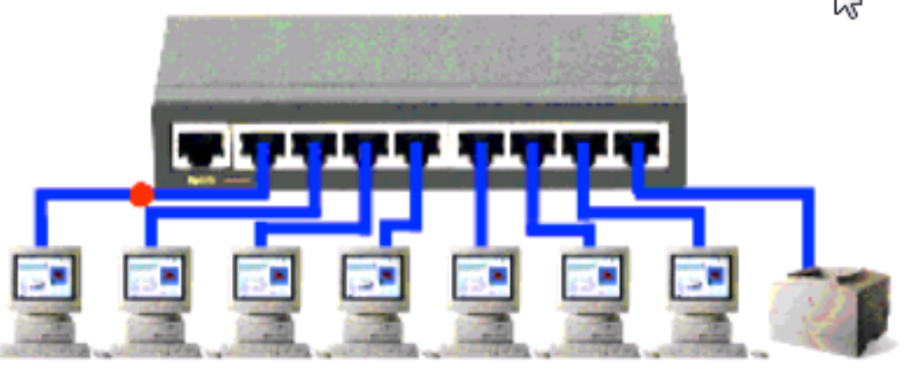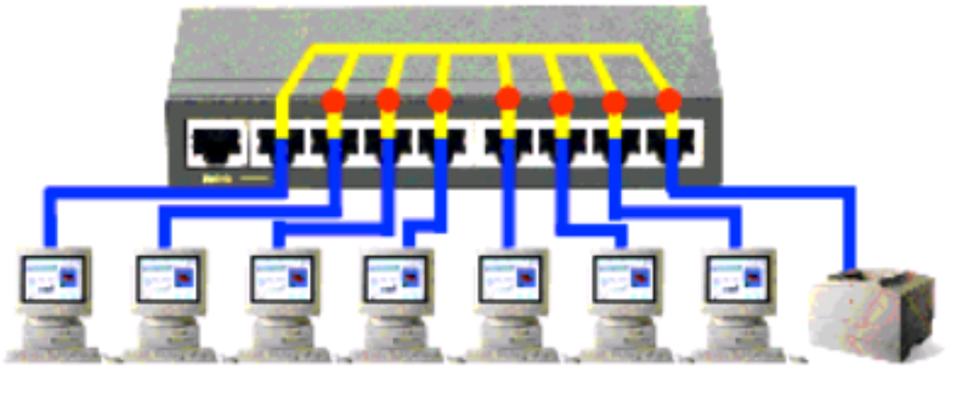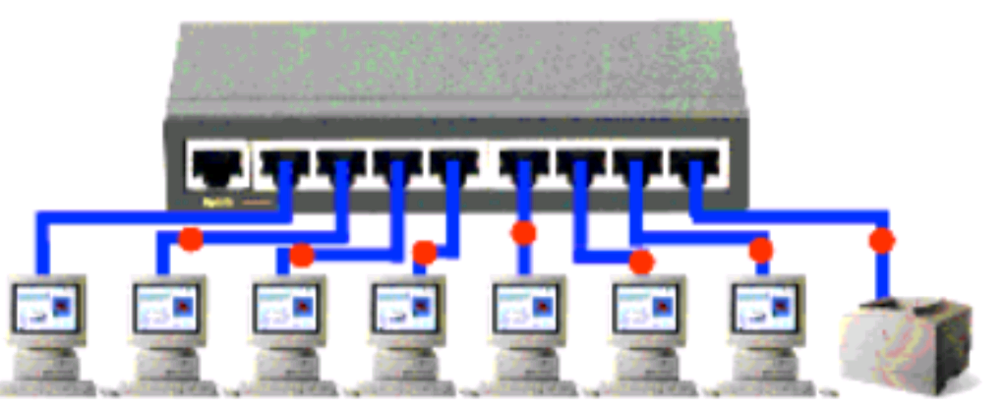

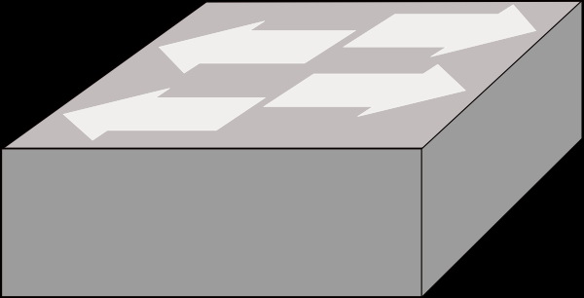**e) Les nœuds : Le switch ou commutateur**

_ _ _ _ _ _ _ _ _ _ _ _ _ _ _ _ _ _ _ _ _ _ _ _ _ _ _ _ _ _ _ _ _ _ _ _ _ _ _ _ _ _ _ _ _ _ _ _ _ _ _ _

_ _ _ _ _ _ _ _ _ _ _ _ _ _ _ _ _ _ _ _ _ _ _ _ _ _ _ _ _ _ _ _ _ _ _ _ _ _ _ _ _ _ _ _ _ _ _ _ _ _ _ _ _ _

_ _ _ _ _ _ _ _ _ _ _ _ _ _ _ _ _ _ _ _ _ _ _ _ _ _ _ _ _ _ _ _ _ _ _ _ _ _ _ _ _ _ _ _ _ _ _ _ _ _ _ _ _ _

_ _ _ _ _ _ _ _ _ _ _ _ _ _ _ _ _ _ _ _ _ _ _ _ _ _ _ _ _ _ _ _ _ _ _ _ _ _ _ _ _ _ _ _ _ _ _ _ _ _ _ _ _ _

Communication logique

Afin d’identifier de manière unique tous les intervenants d’une communication, une adresseest attribuée à tous les **nœuds** d’un réseau. Ainsi, la communication entre deux **nœuds** s’organise comme suit : lorsque l’émetteur envoie une requête sur le réseau, il y attache l’adresse du destinataire.

Ensuite, la requête est envoyée sur le réseau.

Si elle passe par un **switch** en revanche, celui-ci est capable **d’identifier** le destinataire de la requête. Il peut ainsi la relayer au **nœud** concerné uniquement (cf. *Figure 2* ).

Si elle passe par un **hub**, (cf. *Figure 1* *)* celui-ci la redistribue à tous les **nœuds** connectés. Le **nœud** destinataire se reconnaît et peux ainsi traiter la requête. Les autres **nœuds**, qui ne sont pas concernés, ignorent simplement la requête.



***Figure 1 :*** *LAN utilisant un Hub* ***Figure 2 :*** *LAN utilisant un Switch*

Physiquement la connexion temporaire n’est pas simultanée entre les deux hôtes. En fait, chaque **Objet Technique Communicant (OTC)** qui fonctionne en mode bidirectionnel simultané peut transmettre à chaque fois qu’il a une trame, sans tenir compte de la disponibilité de l'OTC de réception. En effet, un commutateur LAN met en mémoire tampon une trame entrante afin de l’envoyer au port correspondant. Ce processus s’appelle **store and forward (stockage et retransmission).** Grâce à ce stockage et à la retransmission, le commutateur reçoit toute la trame, vérifie si elle comporte des erreurs et réachemine la trame vers le port approprié pour l'OTC de destination.

_ _ _ _ _ _ _ _ _ _ _ _ _ _ _ _ _ _ _ _ _ _ _ _ _ _ _ _ _ _ _ _ _ _ _ _ _ _ _ _ _ _ _ _ _ _ _ _ _ _ _ _

_ _ _ _ _ _ _ _ _ _ _ _ _ _ _ _ _ _ _ _ _ _ _ _ _ _ _ _ _ _ _ _ _ _ _ _ _ _ _ _ _ _ _ _ _ _ _ _ _ _ _ _ _ _

_ _ _ _ _ _ _ _ _ _ _ _ _ _ _ _ _ _ _ _ _ _ _ _ _ _ _ _ _ _ _ _ _ _ _ _ _ _ _ _ _ _ _ _ _ _ _ _ _ _ _ _ _ _

_ _ _ _ _ _ _ _ _ _ _ _ _ _ _ _ _ _ _ _ _ _ _ _ _ _ _ _ _ _ _ _ _ _ _ _ _ _ _ _ _ _ _ _ _ _ _ _ _ _ _ _ _ _

_ _ _ _ _ _ _ _ _ _ _ _ _ _ _ _ _ _ _ _ _ _ _ _ _ _ _ _ _ _ _ _ _ _ _ _ _ _ _ _ _ _ _ _ _ _ _ _ _ _ _ _ _ _

_ _ _ _ _ _ _ _ _ _ _ _ _ _ _ _ _ _ _ _ _ _ _ _ _ _ _ _ _ _ _ _ _ _ _ _ _ _ _ _ _ _ _ _ _ _ _ _ _ _ _ _ _ _

_ _ _ _ _ _ _ _ _ _ _ _ _ _ _ _ _ _ _ _ _ _ _ _ _ _ _ _ _ _ _ _ _ _ _ _ _ _ _ _ _ _ _ _ _ _ _ _ _ _ _ _ _ _

**Scénario d'envoi de trames :**

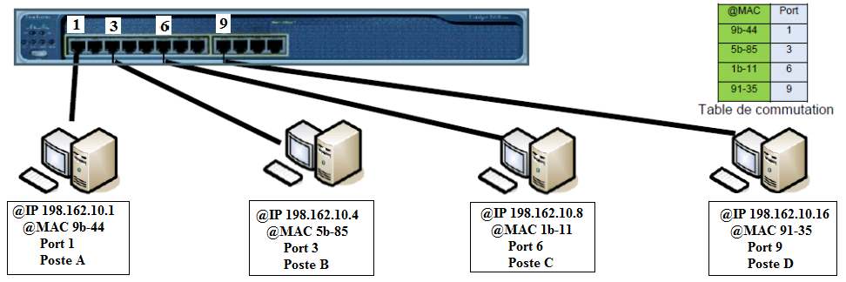

Si l'OTC Poste A envoie une trame au poste D et dans le même temps le Poste B veut envoyer une trame au Poste D, le commutateur va prendre les 2 trames (une entrante sur son port 1, l'autre entrante sur son port 3) va stocker ces trames dans sa mémoire tampon, vérifier si il y a une erreur de checksum, puis en consultant sa table de commutation s'apercevoir que les 2 trames comportent la même adresse MAC de destination correspondant à son port 9, il transmettra donc une première trame (par exemple celle du poste B) en sortie sur son port 9 puis après la seconde trame (celle du poste A).

**f) Les nœuds : le routeur**

_ _ _ _ _ _ _ _ _ _ _ _ _ _ _ _ _ _ _ _ _ _ _ _ _ _ _ _ _ _ _ _ _ _ _ _ _ _ _ _ _ _ _ _ _ _ _ _ _ _ _ _

_ _ _ _ _ _ _ _ _ _ _ _ _ _ _ _ _ _ _ _ _ _ _ _ _ _ _ _ _ _ _ _ _ _ _ _ _ _ _ _ _ _ _ _ _ _ _ _ _ _ _ _ _ _

Pouvoir transmettre une information entre deux **nœuds** appartenant à des **réseaux différents** nécessite quelques fois de traverser plusieurs autres **nœuds** qui appartiennent à **d’autres réseaux**.

_ _ _ _ _ _ _ _ _ _ _ _ _ _ _ _ _ _ _ _ _ _ _ _ _ _ _ _ _ _ _ _ _ _ _ _ _ _ _ _ _ _ _ _ _ _ _ _ _ _ _ _

_ _ _ _ _ _ _ _ _ _ _ _ _ _ _ _ _ _ _ _ _ _ _ _ _ _ _ _ _ _ _ _ _ _ _ _ _ _ _ _ _ _ _ _ _ _ _ _ _ _ _ _ _ _

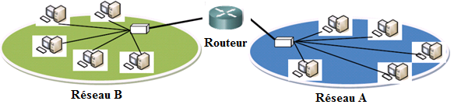

**3. L’architecture**

Les communications dans un réseau s’articulent autour de _ _ _ _ _ _ _ _ _ ou de _ _ _ _ _ _ _ _ _. A l’origine, il y a toujours _ _ _ _ _ _ _ _ _ _ _ _ _ _ _ _ _ _ _ _ _ _ _ _ _ _ _. Par exemple :

* une machine peut demander à une autre de lui envoyer des informations ou des données.
* Elle peut aussi demander à une imprimante d’imprimer un travail.
* Elle peut encore demander à un routeur de transmettre des informations à une troisième machine.

Dans tous les cas cités ci-dessus, il y a un _ _ _ _ _ _ (_ _ _ _ _ _ _ _ _ _ _ _ _ _ _ _ _ _ _ _ _ _ _ _ _ _ _ _ _ _ _ _ _ _ _ _ ) et un _ _ _ _ _ _ _ _ (_ _ _ _ _ _ _ _ _ _ _ _ _ _ _ _ _ _ _ _ _ _ _ _ _ _ _ _ _ _ _ _ _ _ _ _ ). Pour cette raison, on dit que la communication est basée sur une _ _ _ _ _ _ _ _ _ _ _ _ _ _ _ _ _ _ _ _ _ _ _ _ _ _ _ _ _ _ _ _ _ _ _ _ .

Une deuxième forme d’architecture, appelée _ _ _ _ _ _ _ _ _ _ _ _ _ _ _ _ _ _ _ _ _ _ _ _ _ _ , littéralement client à client, implique que les deux nœuds en communication endossent chacun leur tour le rôle du serveur et le rôle du client.



_ _ _ _ _ _ _ _ _ _ _ _ _ _ _ _ _ _ _ _ _ _ _ _ _ _ _ _ _ _ _ _ _ _ _ _ _ _ _ _ _ _ _ _ _ _ _ _ _ _ _ _

_ _ _ _ _ _ _ _ _ _ _ _ _ _ _ _ _ _ _ _ _ _ _ _ _ _ _ _ _ _ _ _ _ _ _ _ _ _ _ _ _ _ _ _ _ _ _ _ _ _ _ _ _ _

*Par exemple*, un ***serveur*** web a pour tâche de distribuer aux éventuels clients les pages web qui lui sont demandées. Un ***serveur*** de messagerie s’occupe de distribuer les courriels des clients qui lui demandent.

Un ***serveur*** peut être dédié à ne répondre qu’à un seul type de requête mais il peut également être prévu pour répondre à plusieurs catégories de requêtes : distribution de pages web, envoi/réception de courriers électroniques, stockage de fichiers.

_ _ _ _ _ _ _ _ _ _ _ _ _ _ _ _ _ _ _ _ _ _ _ _ _ _ _ _ _ _ _ _ _ _ _ _ _ _ _ _ _ _ _ _ _ _ _ _ _ _ _ _

_ _ _ _ _ _ _ _ _ _ _ _ _ _ _ _ _ _ _ _ _ _ _ _ _ _ _ _ _ _ _ _ _ _ _ _ _ _ _ _ _ _ _ _ _ _ _ _ _ _ _ _ _ _

**4. La communication**

**a) Elle peut être filaire.**

_ _ _ _ _ _ _ _ _ _ _ _ _ _ _ _ _ _ _ _ _ _ _ _ _ _ _ _ _ _ _ _ _ _ _ _ _ _ _ _ _ _ _ _ _ _ _ _ _ _ _ _ _ _

**b) Transmission sans fil : WLAN, WPAN**

_ _ _ _ _ _ _ _ _ _ _ _ _ _ _ _ _ _ _ _ _ _ _ _ _ _ _ _ _ _ _ _ _ _ _ _ _ _ _ _ _ _ _ _ _ _ _ _ _ _ _ _ _ _ ;

_ _ _ _ _ _ _ _ _ _ _ _ _ _ _ _ _ _ _ _ _ _ _ _ _ _ _ _ _ _ _ _ _ _ _ _ _ _ _ _ _ _ _ _ _ _ _ _ _ _ _ _

_ _ _ _ _ _ _ _ _ _ _ _ _ _ _ _ _ _ _ _ _ _ _ _ _ _ _ _ _ _ _ _ _ _ _ _ _ _ _ _ _ _ _ _ _ _ _ _ _ _ _ _ _ _

b1) transmission sans fil **WLAN** : **Wi-Fi** **[ _ _ _ _ _ _ _ _ _ _ _ _ _ _ _ _ _ _ _ _ _ _ _ _ ] :**

_ _ _ _ _ _ _ _ _ _ _ _ _ _ _ _ _ _ _ _ _ _ _ _ _ _ _ _ _ _ _ _

_ _ _ _ _ _ _ _ _ _ _ _ _ _ _ _ _ _ _ _ _ _ _ _ _ _ _ _ _ _ _ _ _ _ _ _ _ _ _ _ _ _ _ _ _ _ _ _ _ _ _ _ _ _ _ _ _ _ _ _ _ _ _ _ _ _ _ _ _ _ _ _ _ _ _ _ _ _ _ _ _ _ _ _ _ _ _ _ _ _ _ _ _ _ _ _ _ _ _ _ _ _ _ _ _ _ _ _ _ _ _ _ _ _ _ _ _ _ _ _ _ _ _ _ _ _ _ _ _ _ _ _ _ _ _ _ _ _ _ _ _ _ _ _ _ _ _ _ _ _ _ _ _ _ _ _ _ _ _ _

La portée théorique pour cette technologie est de _ _ _ _ _ _ _ _ _ _ _ _ _ _ _ _ _ _ _ _ _ _ _ _, dans un espace ouvert et sans aucun obstacle ; la portée se réduit considérablement en espace fermé et suivant les obstacles rencontrés mais _ _ _ _ _ _ _ _ _ _ _ _ _ _ _ _ _ _ _ _ _ _ _ _ _ _ _ _ _ _ _ _ _ _ _ _ _ _ _ _ _ _ _ _ _ _ _ _ _ _ _ _ _ _ _ .

Plusieurs normes existent :

_ _ _ _ _ _ _ _ _ _ _ _ _ _ _ _ _ _ _ _ _ _ _ _ _ _ _

_ _ _ _ _ _ _ _ _ _ _ _ _ _ _ _ _ _ _ _ _ _ _ _ _ _ _

_ _ _ _ _ _ _ _ _ _ _ _ _ _ _ _ _ _ _ _ _ _ _ _ _ _ _

* **Modes de mise en réseau**

Il existe deux modes de mise en réseau pour les **WLAN** (ou réseau **Wi-Fi**) :

_ _ _ _ _ _ _ _ _ _ _ _ _ _ _ _ _ _ _ _ _ _ _ _ _ _ _ _ _ _ _ _ _ _ _ _ _ _ _ _ _ _ _ _ _ _ _ _ _ _ _ _

Le mode _ _ _ _ _ _ _ _ _ _ _ _ _ _ _ _ _ _ _ _ _ _ _ _ _ _ _ _ _ _ _ _ _ _ _ _ _ _ _ _ _ _ _ _ _ _ _

_ _ _ _ _ _ _ _ _ _ _ _ _ _ _ _ _ _ _ _ _ _ _ _ _ _ _ _ _ _ _ _ _ _ _ _ _ _ _ _ _ _ _ _ _ _ _ _ _ _ _ _ _ _

_ _ _ _ _ _ _ _ _ _ _ _ _ _ _ _ _ _ _ _ _ _ _ _ _ _ _ _ _ _ _ _ _ _ _ _ _ _ _ _ _ _ _ _ _ _ _ _ _ _ _ _ _ _

Le mode _ _ _ _ _ _ _ _ _ _ _ _ _ _ _ _ _ _ _ _ _ _ _ _ _ _ _ _ _ _ _ _ _ _ _ _ _ _ _ _ _ _ _ _ _ _ _

_ _ _ _ _ _ _ _ _ _ _ _ _ _ _ _ _ _ _ _ _ _ _ _ _ _ _ _ _ _ _ _ _ _ _ _ _ _ _ _ _ _ _ _ _ _ _ _ _ _ _ _ _ _

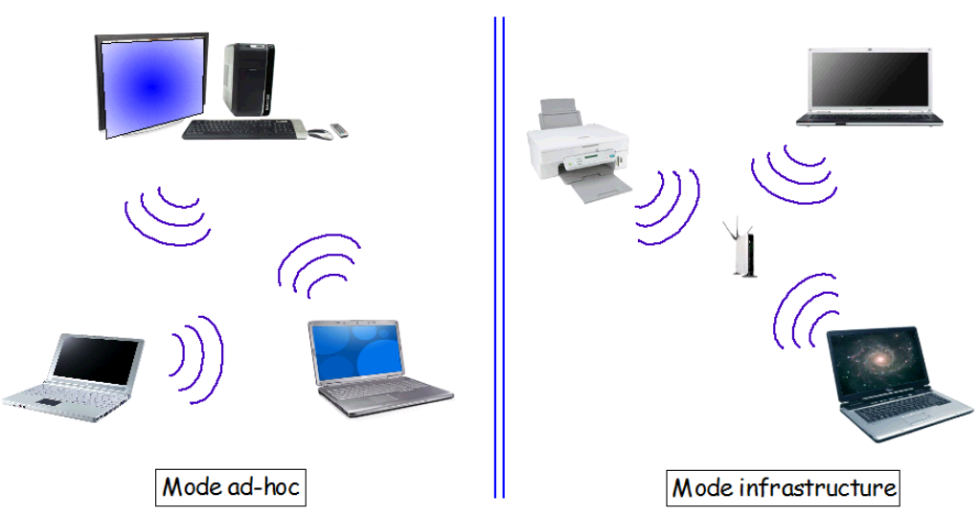

***Figure 3 :*** *mode ad-hoc et mode infrastructure*

b2) transmission sans fil **WPAN** : **Bluetooth** (norme 802.15) et **infrarouge**

WPAN= _ _ _ _ _ _ _ _ _ _ _ _ _ _ _ _ _ _ _ _ _ _ _ _ _ _ _ _ _ _ _ _ _ _ _ _ _ _ _ _ _ _ _ _ _ _ _ _ _ _ _ _ _ _ _ _ _ _ _ _ _ _ _ _ _ _ _ _ _ _ _ _ _ _ _ _ _ _ _ _ _ _ _ _ _ _ _ _ _ _ _ _ _ _ _ _ _ _ _ _ _ _ _ _

_ _ _ _ _ _ _ _ _ _ _ _ _ _ _ _ _ _ _ _ _ _ _ _ _ _ _ _ _ _ _ _ _ _ _ _ _ _ _ _ _ _ _ _ _ _ _ _ _ _ _ _ _ _

* **La liaison Bluetooth**

Même bande de fréquence que pour la liaison **Wi-Fi**, elle est donc soumise aux mêmes inconvénients, à savoir le partage de cette bande avec la transmission sans fil d'autres matériels (comme les caméras de surveillance sans fils) mais également le fonctionnement d'appareils utilisant cette bande de fréquence, tel **les fours micro-ondes**.

La portée ainsi que le débit sont bien moindre que pour le **Wi-Fi** (dépend de la classe du réseau) : d'une centaine de mètre (classe 1) à une dizaine mètre (classe 3).

Cette liaison bas débit (_ _ _ _ _ _ _ _ _ _ _ _ ) a été conçue au départ dans le but _ _ _ _ _ _ _ _ _ _ _ _ _ _ _ _ _ _ _ _ _ _ _ _ entre l'unité centrale et les périphériques proches (imprimante, appareil photo numérique, clavier, ...). _ _ _ _ _ _ _ _ _ _ _ __ _ _ _ _ _ _ _ _ _ _

* **La liaison infrarouge**

_ _ _ _ _ _ _ _ _ _ _ _ _ _ _ _ _ _ _ _ _ _ _ _ _ _ _ _ _ _ _ _ _ _ _ _ _ _ _ _ _ _ _ _ _ _ _ _ _ _ _ _ _ _ _ _ _ _ _ _ _ _ _ _ _ _ _ _ _ _ _ _ _ _ _ _ _ _ _ _ _ _ _ _ _ _ _ _ _ _ _ _ _ _ _ _ _ _ _ _ _ _ _ _ _ _ _ _ _ _ _ _ _ _ _ _ _ _ _ _ _ _ _ _ _ _ _ _ _ _ _ _ _ _ _ _ _ _ _ _ _ _ _ _ _ _ _ _ _ _ _ _ _ _ _ _ _ _ _ _ _ _ _ _ _ _ _ _ _ _ _ _ _ _ _ _ _ _ _ _ _ _ _ _ _ _ _ _ _ _ _ _ _ _ _ _ _ _ _ _ _ _ _ _ _ _

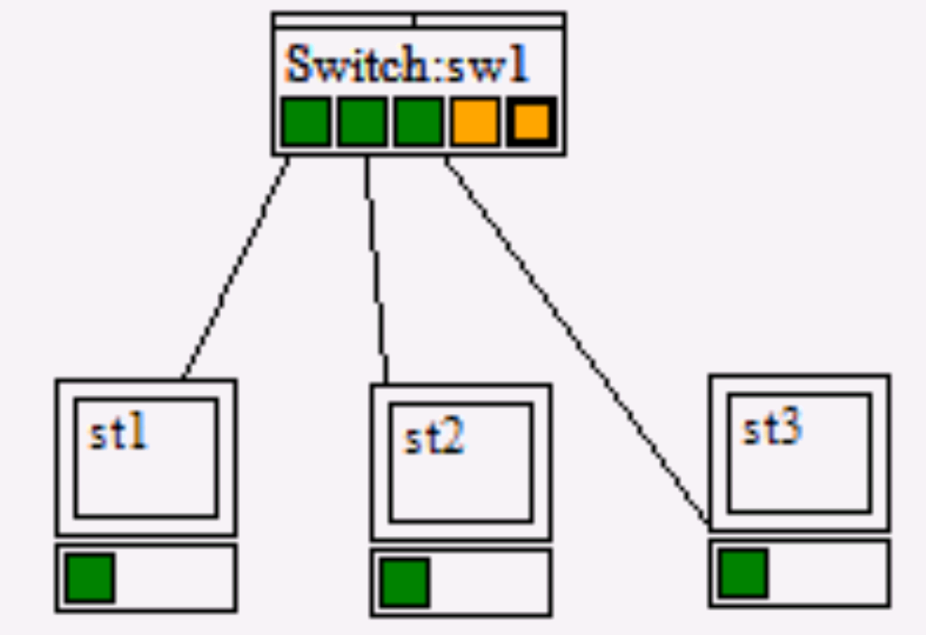

Bien souvent dans les réseaux, les ***nœuds*** sont de natures différentes :

par exemple comment le poste1 va savoir comment envoyer

un message au poste2 et non au poste3, et que ce message soit bien reçu.

Pour que la communication puisse avoir lieu entre ces deux ***nœuds***, il est nécessaire qu’ils utilisent un langage commun ; _ _ _ _ _ _ _ _ _ _ _ _ _ _ _ _ _ _ _ _ _ _ _ _ _ _ _ _ _ _ _ _ _ _ _ _ _ _ _ _ _ _ _ _ _ _ _ _ _ _ _ _ _ _ _ _ _ _ _ _ _ _ _ _ _ _ _ _ _ _ _ _ _ _ _ _ _ _ _ _ _ _ _ _ _ _ _ _ _ _ _ _ _ _ _ _ _ _ _ _ _ _ _ _ _ _ _ _ _ _ _ _ _ _ _ _ _ _ _ _ _ _ _ _ _ _ _ _ _ _ _ _ _ _ _ _ _ _ _ _***.***

Un protocole permet de standardiser la forme des informations échangées indépendamment du type d’OTC utilisées. Il détermine les stratégies d’acheminement des données et les procédures à effectuer en cas d’erreur.

_ _ _ _ _ _ _ _ _ _ _ _ _ _ _ _ _ _ _ _ _ _ _ _ _ _ _ _ _ _ _ _ _ _ _ _ _ _ _ _ _ _ _ _

**5. Les protocoles**

Dans les années 80 le domaine des réseaux est très prolifique et de nombreux standards existaient (X400, TCP/IP, Ethernet, X25, IIEEE802…). _ _ _ _ _ _ _ _ _ _ _ _ _ _ _ _ _ _ _ _ _ _ _ _ _ _ _ _ _ _ _ _ _ _ _ _ _ _ _ _ _ _ _ _ _ _ _ _ _ _ _ _ _ _ _ _ _ _ _ _ _ _ _ _ _ _ _ _ _ _ _ _ _ _ _ _ _ _ _ _ _ _ _ _ _

TCP/IP signifie _ _ _ _ _ _ _ _ _ _ _ _ _ _ _ _ _ _ _ _ _ _ _ _ _ _ _ _ _ _ _ _ _ _ _ _ _ _ _ _ _ _ _ _ (la notation TCP/IP se prononce "T-C-P-I-P") soit en français: Protocole de Contrôle de Transmission / Protocole Internet.

Il représente la façon dont les ordinateurs communiquent sur Internet. Pour cela, il se base _ _ _ _ _ _ _ _ _ _ _ _ _ _ _ _ _ _ _ _ _ _ _ _ _ _ _ _ _ _ _ _ _ _ _ _ _ _ _ _ _ _ _ _ _ _ _ _ _ _ _ _ _ _ _ _ _ .

_ _ _ _ _ _ _ _ _ _ _ _ _ _ _ _ _ _ _ _ _ _ _ _ _ _ _ _ _ _ _ _ _ _ _ _ _ _ _ _ _ _ _ _ _ _ _ _ _ _ _ _ _ _ _ _ .

Le modèle TCP/IP s'inspire du modèle _ _ _ _ _ _ _

(_ _ _ _ _ _ _ _ _ _ _ _ _ _ _ _ _ _ _ _ _ _ _ _ _ _ _ _ _ _ _ _ _ _ _ _ _ _ _ _ _ _ _ _ _ _ _ _ _ _ _ ).

**a) Le modèle OSI**

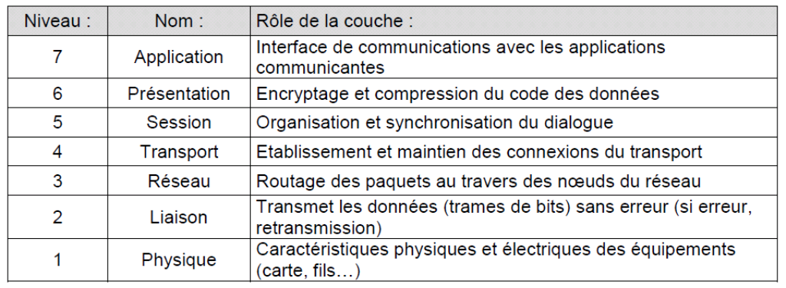C’est un modèle qui comporte _ _ _ _ _ _ _ _ _ et qui a été mis au point par l'Organisation Internationale des Standards (ISO, international standard organisation) afin de normaliser les communications entre ordinateurs.

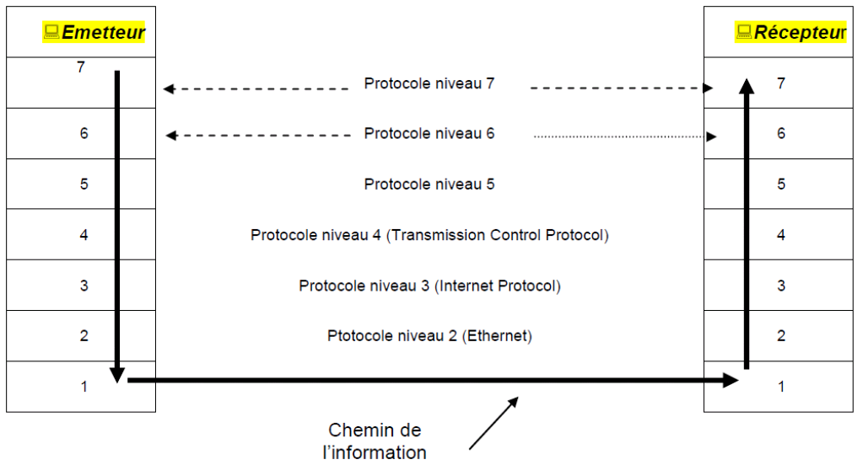

Le modèle TCP/IP, inspiré du modèle OSI, contient uniquement quatre couches:

|  |  |  |
| --- | --- | --- |
| **Modèle TCP/IP** | | **Modèle OSI** |
| Programmes de l’utilisateur | Couche Application *Applications réseau (Http, ftp,Pop, SMTP…)* | Couche Application |
| *Couche Présentation* |
| *Couche Session* |
| **Logiciels dans le système** | **Couche Transport (TCP*****ou UDP*)** | *Couche Transport* |
| **Adressage IP** | **Couche Internet (IP)**  ***(protocole IP, ARP, RARP, ICMP)*** | *Couche Réseau* |
| **Adressage matériel**  **Carte réseau Ethernet** | **Couche Accès réseau**  ***(protocole FTS, FDDI, PPP, Ethernet, CSMA/CD)*** | *Couche Liaison données* |
| *Couche Physique* |

Les rôles des différentes couches sont les suivants :

***Couche Application*** : elle englobe les applications standards du réseau (Telnet, SMTP, FTP, ..)

***Couche Transport*** : elle assure l'acheminement des données, ainsi que les mécanismes permettant de connaître l’état actuel de la transmission

***Couche Internet*** : elle est chargée de fournir le paquet de données (datagramme)

***Couche accès réseau*** : spécifie la forme sous laquelle les données doivent être acheminées quelque soit le type de réseau utilisé

**b) Le protocole TCP**

* **Les caractéristiques du protocole TCP**

_ _ _ _ _ _ _ _ _ _ _ _ _ _ _ _ _ _ _ _ _ _ _ _ _ _ _ _ _ _ _ _ _ _ _ _ _ _ _ _ _ _ _ _ _ _ _ _ _ _ _ _ .

TCP est un protocole orienté **connexion**, c'est-à-dire qu'il permet à deux machines qui communiquent de contrôler l'état de la transmission.

Lors d'une communication à travers le protocole TCP, les deux machines doivent établir une connexion. _ _ _ _ _ _ _ _ _ _ _ _ _ _ _ _ _ _ _ _ _ _ _ _ _ _ _ _ _ _ _ _ _ _ _ _ _ _ _ _ _ _

Pour permettre le bon déroulement de la communication et de tous les contrôles qui l'accompagnent, les données sont encapsulées, c'est-à-dire qu'on ajoute aux paquets de données un en-tête qui va permettre de synchroniser les transmissions et d'assurer leur réception.

**c) Les adresses IP**

**Qu'est-ce qu'une adresse IP**

Chaque hôte, (noeud d'un réseau TCP/IP impliqué dans le réseau Internet) que ce soit une station de travail, un routeur ou un serveur, doit avoir une adresse **IP unique.**

Cette adresse ne dépend pas du matériel utilisé pour relier les machines ensemble, c'est une adresse logique notée sous forme de : w.x.y.z

Exemple d'adresses IP : **212.217.0.12 193.49.148.60 87.34.53.12**

**Anatomie d’une adresse IP**

* + _ _ _ _ _ _ _ _ _ _ _ _ _ _ _ _ _ _ _ _ _ _ _ _ _ _ _ _ _ _ _ _ _ _ _ _ _ _ _ _ _ _ _ _ _ _ _ _ _ _ _ _ _ _ _ _ _ _ _ _ _ _ _ _ _ _ _ _ _ _ _ _ _ _ _ _ _ _ _ _ _ _ _ _ _ _ _ _ _ _ _ _ _ _ _ _ _ _ _ _ _ _ _ _ _ _ _ _ _ _ _ _ _ _ _ _ _ _ _ _ _ _ _ _ _ _ _ _ _ _ _ _ _ _ _ _ _ _ _ _ _ _ _ _ _ _ _ _ _ _ _ _ _ _ _ _ _ _ _ _ _ _ _ _ _ _ _ _ _ _ _ _ _ _ _ _ _ _ _ _ _ _ _ _ _ _ _ _ _.
  + On trouve souvent cette adresse avec des valeurs décimales, mais il est possible de l’écrire sous forme binaire (c’est parfois indispensable)

Exemple : L’adresse IP : **212. 217. 0. 1**

correspond à la notation binaire: _ _ _ _ _ _ _ _ _ _ _ _ _ _ _ _ _ _ _ _ _ _ _ _ _ _

* Chaque nombre est compris entre 0 et 255, soit en binaire entre **00000000 et 11111111**
* _ _ _ _ _ _ _ _ _ _ _ _ _ _ _ _ _ _ _ _ _ _ _ _ _ _ _ _ _ _ _ _ _ _ _ _ :
* Une partie nommée Identificateur (ID) du réseau : _ _ _ _ _ _ _ _ située à gauche, _ _ _ _ _ _ _ _ _ _ _ _ _ _ _ _ _ _ _ _ _ _ _ _ _ _ _ _ _ _ _ _ _ _ _ _ _ _ _ _ _ _ _ _ _ _ _ _ _.
* Une autre partie nommée identificateur de l'hôte : _ _ _ _ _ _ _ _ située à droite _ _ _ _ _ _ _ _ _ _ _ _ _ _ _ _ _ _ _ _ _ _ _ _ _ _ _ _ _ _ _ _ _ _ _ _ _ _ _ _ _ _ _ _ _ _ _ _ _.

|  |  |  |
| --- | --- | --- |
| ←---------------------------------------4 octets--------------------------------------------→ | | |
| **_ _ _ _ _ _ _ _ _ _ _ _ _** | **_ _ _ _ _ _ _ _ _ _ _ _** | |
| **Identifiant du réseau** | **Identifiant du hôte** | |

* Pour savoir où se situe la limite entre net-ID et host-ID, il faut connaitre **_ _ _ _ _ _ _ _ _ _ _ _.**

**Deux adresses particulières**

Parmi les adresses possibles, deux sont spécifiques et ne doivent pas être utilisées par des machines :

* Tous les bits de la partie **Host-ID sont à 0 :** C’est ***l’adresse du réseau***

***Ex : 192.168.10.0 = 192.168.10.00000000***

* Tous les bits de la partie **Host-ID sont à 1**: C’est l’adresse de diffusion (**_ _ _ _ _ _ _ _ _ _**) utilisée pour ***communiquer avec toutes les machines du réseau***.

***Ex : 172.27.255.255 = 172.27.11111111.11111111***

**Classes d’adresses IP.**

**Les adresses de classe A.**

_ _ _ _ _ _ _ _ _ _ _ _ _ _ _ _ _ _ _ _ _ _ _ _ _ _ _ _ _ _ _ _ _ _ _ _ _ _ _ _ _ _ _ _ _ _ _ _ _ _ _ _ _ _ _ _ _ _ _ _ _ _ _ _ _ _ _ _ _ _ _ _ _ _ _ _ _ _ _ _ _ _ _ _ _ _ _ _ _ _ _ _ _ _ _ __ _ _ _ _ _ _ _ _ _ _ _ _ _ _ _ _

Net-ID (Réseau)

Host-ID (Stations)

XXXX XXXX

**0**XXX XXXX

XXXX XXXX

XXXX XXXX

***Voir TD réseau n°1*** pour le calcul des adresses

**Les adresses de classe B.**

_ _ _ _ _ _ _ _ _ _ _ _ _ _ _ _ _ _ _ _ _ _ _ _ _ _ _ _ _ _ _ _ _ _ _ _ _ _ _ _ _ _ _ _ _ _ _ _ _ _ _ _ _ _ _ _ _ _ _ _ _ _ _ _ _ _ _ _ _ _ _ _ _ _ _ _ _ _ _ _ _ _ _ _ _ _ _ _ _ _ _ _ _ _ _ __ _ _ _ _ _ _ _ _ _ _ _ _ _ _ _ _

XXXX XXXX

**10**XX XXXX

XXXX XXXX

XXXX XXXX

Host-ID (Stations)

Net-ID (Réseau)

***Voir TD réseau n°1*** pour le calcul des adresses

**Les adresses de classe C.**

_ _ _ _ _ _ _ _ _ _ _ _ _ _ _ _ _ _ _ _ _ _ _ _ _ _ _ _ _ _ _ _ _ _ _ _ _ _ _ _ _ _ _ _ _ _ _ _ _ _ _ _ _ _ _ _ _ _ _ _ _ _ _ _ _ _ _ _ _ _ _ _ _ _ _ _ _ _ _ _ _ _ _ _ _ _ _ _ _ _ _ _ _ _ _ __ _ _ _ _ _ _ _ _ _ _ _ _ _ _ _ _

XXXX XXXX

**110**X XXXX

XXXX XXXX

XXXX XXXX

Net-ID (Réseau)

Host-ID (Stations)

***Voir TD réseau n°1*** pour le calcul des adresses

**Autres classes.**

Il existe une classe D (qui commence par 1110) mais cette classe d’adresse n’est pas utilisée pour adresser des machines individuelles. Ce sont des adresses appelées **multicast** qui permettent par exemple d’envoyer de la vidéo sur plusieurs machines simultanément.

|  |  |  |
| --- | --- | --- |
|  | **Binaire** | **Décimal** |
| 1ère adresse de réseau |  |  |
| Dernière adresse de réseau |  |  |

Enfin, les réseaux dont l’adresse commence par 11111 sont des réseaux de classe E. Ces adresses sont réservées et donc ne sont pas utilisées pour adresser des machines.

|  |  |  |
| --- | --- | --- |
|  | **Binaire** | **Décimal** |
| 1ère adresse de réseau |  |  |
| Dernière adresse de réseau |  |  |

**Adresses non utilisées :**

Certaines adresses réseaux ne sont pas utilisées pour adresser des machines. Il s’agit des réseaux :

* 0.X.X.X Le premier réseau. La première adresse 0.0.0.0 désigne les réseaux inconnus.
* 127.X.X.X Ce réseau désigne l’ordinateur lui-même (localhost = 127.0.0.1). Cette adresse est dite de bouclage. Elle permet notamment d’effectuer des tests.

**IP publique, IP privée.**

Le schéma ci-dessous présente un réseau local relié à Internet par un routeur. Ce routeur possède deux adresses IP :

Une IP publique, achetée ou fournie par le FAI.

Une IP privée, librement paramétrée par l’administrateur du réseau local.

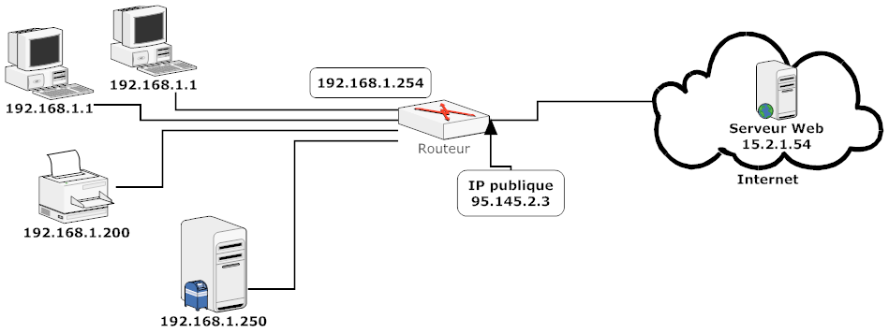

L'organisme gérant l'espace d'adressage public (adresses **IP** routables) est l'*Internet Assigned Number Authority* (**IANA**).

La RFC 1918 définit un espace d'adressage privé permettant à toute organisation d'attribuer des adresses **IP** aux machines de son réseau interne sans risque d'entrer en conflit avec une adresse **IP** **publique** allouée par l'IANA. Ces adresses dites non-routables correspondent aux plages d'adresses suivantes :

* **Classe A : plage de 10.0.0.0 à 10.255.255.255 ;**
* **Classe B : plage de 172.16.0.0 à 172.31.255.255 ;**
* **Classe C : plage de 192.168.0.0 à 192.168.255.255**

En résumé :

* Les_ _ _ _ _ _ _ _ _ _ _ _ _ _ _ _ _ _ _ _ _ _ _ _ _ _ _ _ _ _ _ _ _ _ _ _ _ _ _ _ _ _ _ _
* Les_ _ _ _ _ _ _ _ _ _ _ _ _ _ _ _ _ _ _ _ _ _ _ _ _ _ _ _ _ _ _ _ _ _ _ _ _ _ _ _ _ _ _ _

Un modem-routeur connecté à Internet possède donc une IP privée (coté LAN) et une IP publique (côté WAN).

**Masque de réseau.**

Pour que le réseau Internet puisse router (acheminer) les paquets de données, il faut qu’il connaisse l’adresse du réseau de destination. Pour déterminer cette adresse réseau à partir de l’adresse IP de destination, on utilise ***le masque de sous réseau***.

_ _ _ _ _ _ _ _ _ _ _ _ _ _ _ _ _ _ _ _ _ _ _ _ _ _ _ _ _ _ _ _ _ _ _ _ _ _ _ _ _ _ _ _ _ _ _ _ _ _ _ _ _ _ _ _ _ _ _ _ _ _ _ _ _ _ _ _ _ _ _ _ _ _ _ _ _ _ _ _ _ _ _ _ _ _ _ _ _ _ _ _ _ _ _ _ _ _ _ _ _ _ _ _ _ _ _ _ _ _ _ _ _ _ _ _ _ _ _ _ _ _ _ _ _ _ _ _ _ _ _ _ _ _ _ _ _ _ _ _ _ _ _ _ _ _ _ _ _ _ _ _ _ _ _ _ _ _ _ _ _ _ _ _ _ _

|  |  |  |
| --- | --- | --- |
| **Classes d'adresses** | **Bits utilisés pour le masque de sous -réseau** | **Notation décimale** |
| **A** | **1111 1111 0000 0000 0000 0000 0000 0000** | **255.0.0.0** |
| **B** | **1111 1111 1111 1111 0000 0000 0000 0000** | **255.255.0.0** |
| **C** | **1111 1111 1111 1111 1111 1111 0000 0000** | **255.255.255.0** |

Un «ET» logique appliqué entre le masque de réseau et l’adresse IP permet d’obtenir l’adresse d’un réseau correspondant.

***Exemple :***

Soit l’adresse IP 12.32.23.15 appartenant à un poste informatique quelconque , il s’agit d’une adresse de classe A.

Pour déterminer l’adresse du réseau, on va faire un ET Logique avec son masque par défaut.

|  |  |
| --- | --- |
| Adresse binaire de 12.32.23.15 | 00001100.00100000.00010111.00001111 |
| Masque réseau en binaire 255.0.0.0 | 11111111.00000000.00000000.00000000 |
| ET Logique entre les deux | 00001100.00000000.00000000.00000000 |
| On remet en décimal | 12.0.0.0 = adresse du réseau |

Dans le masque réseau :

* les bits positionnés à 1 sont associés au numéro de réseau (***Net-id***)
* les bits positionnés à 0 correspondent à la partie hôte. (***Host-id***) et vont permettre de déterminer le nombre de machines appartenant à un réseau.

**Calcul de masque de sous réseau 2 postes**

Poste 1

|  |  |  |  |  |  |  |  |  |  |  |  |  |  |  |  |  |  |  |  |  |  |  |  |  |  |  |  |  |  |  |  |
| --- | --- | --- | --- | --- | --- | --- | --- | --- | --- | --- | --- | --- | --- | --- | --- | --- | --- | --- | --- | --- | --- | --- | --- | --- | --- | --- | --- | --- | --- | --- | --- |
|  |  |  | 1 | 0 | 0 |  |  |  |  |  | 0 | 5 | 0 |  |  |  |  |  | 0 | 2 | 5 |  |  |  |  |  | 0 | 0 | 1 |  |  |
|  |  |  |  |  |  |  |  |  |  |  |  |  |  |  |  |  |  |  |  |  |  |  |  |  |  |  |  |  |  |  |  |

Poste 2

|  |  |  |  |  |  |  |  |  |  |  |  |  |  |  |  |  |  |  |  |  |  |  |  |  |  |  |  |  |  |  |  |
| --- | --- | --- | --- | --- | --- | --- | --- | --- | --- | --- | --- | --- | --- | --- | --- | --- | --- | --- | --- | --- | --- | --- | --- | --- | --- | --- | --- | --- | --- | --- | --- |
|  |  |  | 1 | 0 | 0 |  |  |  |  |  | 0 | 5 | 0 |  |  |  |  |  | 0 | 2 | 0 |  |  |  |  |  | 0 | 0 | 1 |  |  |
|  |  |  |  |  |  |  |  |  |  |  |  |  |  |  |  |  |  |  |  |  |  |  |  |  |  |  |  |  |  |  |  |

Masque de sous-Réseau

|  |  |  |  |  |  |  |  |  |  |  |  |  |  |  |  |  |  |  |  |  |  |  |  |  |  |  |  |  |  |  |  |
| --- | --- | --- | --- | --- | --- | --- | --- | --- | --- | --- | --- | --- | --- | --- | --- | --- | --- | --- | --- | --- | --- | --- | --- | --- | --- | --- | --- | --- | --- | --- | --- |
|  |  |  |  |  |  |  |  |  |  |  |  |  |  |  |  |  |  |  |  |  |  |  |  |  |  |  |  |  |  |  |  |
|  |  |  |  |  |  |  |  |  |  |  |  |  |  |  |  |  |  |  |  |  |  |  |  |  |  |  |  |  |  |  |  |

Ainsi, à l’aide du masque de réseau, on peut donc définir, pour toute adresse IP :

* L’adresse réseau associée,
  + Dans l’exercice précédent :
* La partie hôte associée,
  + Dans l’exercice précédent :
* L’adresse de diffusion associée qui désigne tous les hôtes de ce réseau (partie hôte à 1)
  + Dans l’exercice précédent :

**Trois adresses spéciales**

Il existe dans les réseaux trois types d’adresses, les adresses locales, les adresses de **broadcast**, et les adresses multicast.

Pour résumer :

* Je parle directement à quelqu’un (**unicast**)
* Je parle à tout le monde (**broadcast**)
* Je parle à un groupe restreint (**multicast)**